Ship to Amazon Warehouse Setup Instructions

Amazon Seller Account:

Register in Amazon Web Services

- Register for "Amazon Web Service" - http://mws.amazon.com
Register for Amazon Marketplace Webservice and find AccessKeyID & SecretAcesssKey

- Login to "Amazon Web Service" - https://sellercentral.amazon.com/gp/mws/registration/register.html
- It will show 3 options after you login. Choose the one says "I want to access my own Amazon seller account with MWS"
- Click next and complete the process. After completing it will give you the credentials for developer account. Copy and save it in your system before leaving the page.
- Copy “Merchant ID, MarketPlace ID, AWS Access Key ID and Secret Key” and send to http://support.acutrack.com

Please contact Amazon support for any question regarding Amazon seller account setup.

Here are the steps to setup the Single address shipment.

- Login to https://sellercentral.amazon.com
- Navigate to Settings >>> Fulfillment By Amazon
- Click "Edit" from "Inbound Settings"
- Choose “Inventory Placement Service” and Click Update.

Note: A per unit service fee will be charged by Amazon to this single address shipment option.

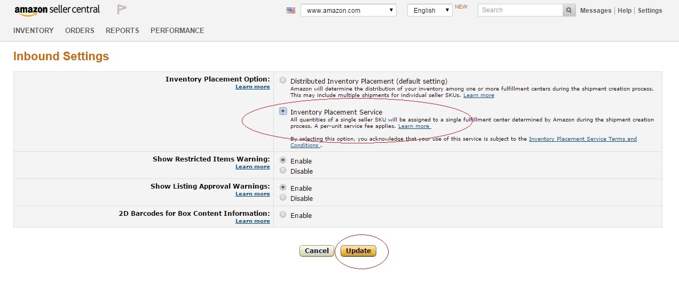

Place Order:

- Please make sure the Amazon ProductId and Acutrack ProductId are same.
- Then place order at Acutrack customer portal http://www.acutrack.com/customerportal
- When placing order, select “Ship to Amazon” in the shipping address screen.

